**Scenario 1: Process Monthly Interest**

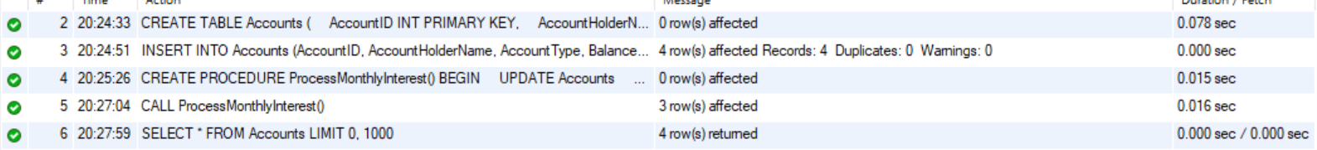

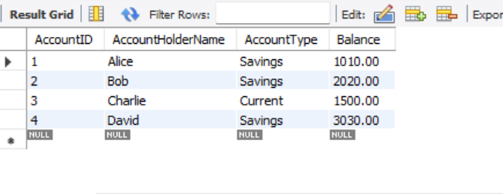

**Scenario 2: Employee Bonus Update**

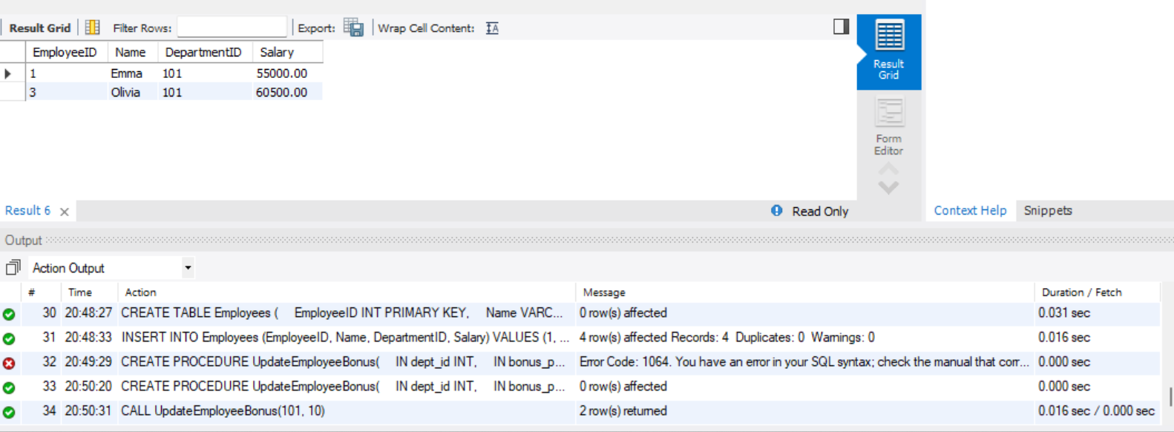

Scenario 3: Transfer Funds

